**HUMIDITY READINGS USING RASBERRY Pi 3, DHT22 SENSOR and PYTHON PROGRAMMING**

Using some simple Python code and a Raspberry Pi, the DHT22 will allow real-time humidity readings to be read to the Pi, with reasonable accuracy. The Raspberry Pi DHT22 sensor makes for an affordable, easy-to-use, and reliable sensor due to its simple 4-pin wiring and greater accuracy.

**Components Required**

* Raspberry Pi 3
* Breadboard
* Male-Female Jumper Wires (3)
* DHT22 Temperature & Humidity Sensor
* 10KΩ resistor

**DHT22 Raspberry Pi Connection**

In the diagram below, a 10KΩ pull-up resistor is added between the VCC and data pin of the DHT22 sensor. This resistor is needed to sustain a HIGH signal to the microcontroller (Raspberry Pi) and maintain constant communication between the sensor and the Pi.

* I connected VCC (Pin 1) to 5v (Pin 04) on my Raspberry Pi 3,
* the Data pin (Pin 2) to GPIO04 (Pin 07)
* and GND (Pin 4) to GND (Pin 06) on the Raspberry Pi
* I connected a 10KΩ resistor between the VCC (Pin 1) and Data pin (Pin 2) on the DHT22 sensor.

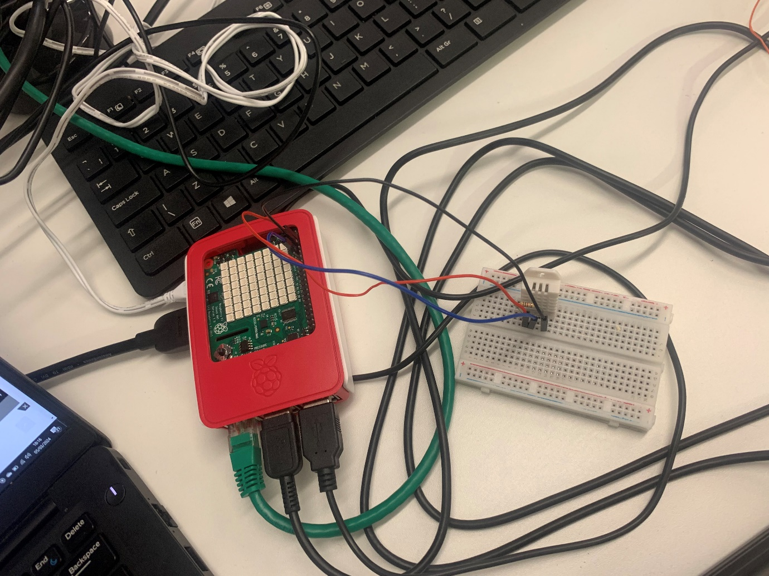

Figure 1

The Thorny Snapshots containing the Python Code below:

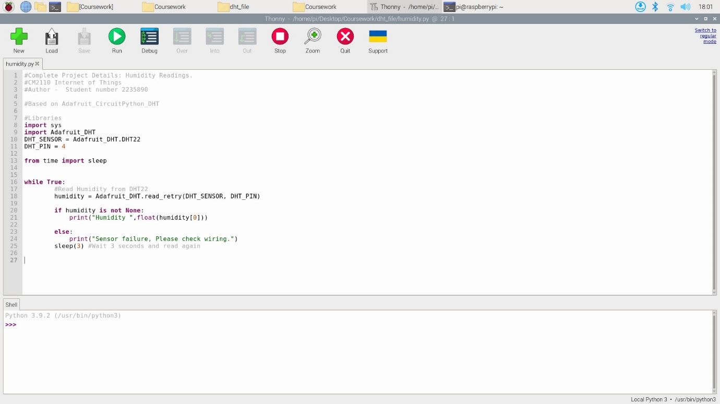

Figure 2

Getting the humidity readings on the Thorny Python Shell:

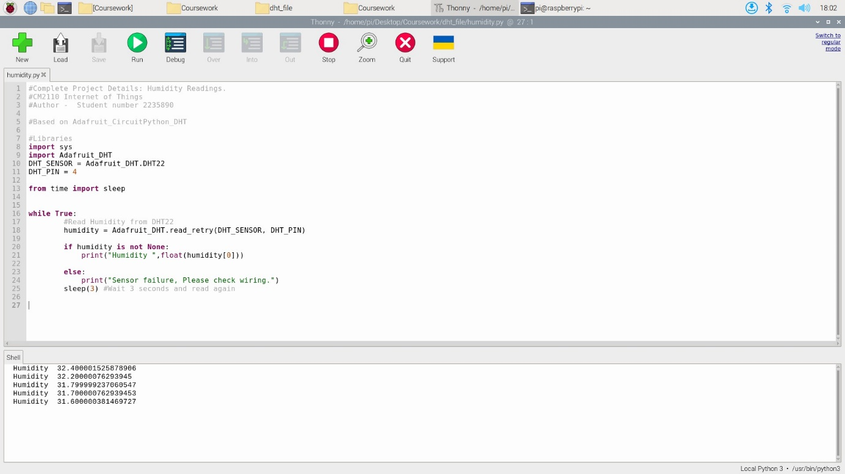

Figure 3

**The commands used:**

Created a directory on the Desktop, named Coursework, and another directory in the coursework folder named dht_file.

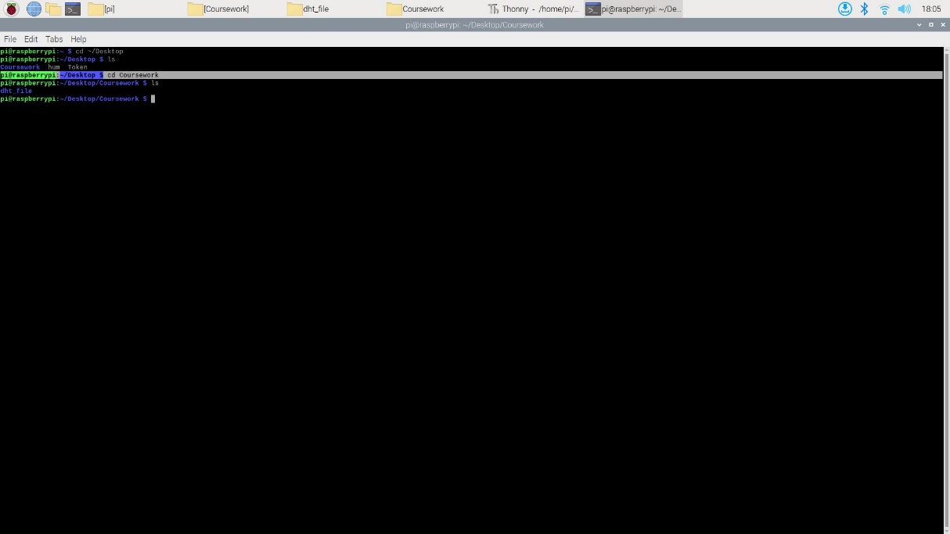

Figure 4

I installed the DHT library in a virtual environment. Creating a virtual environment will isolate the Python libraries we’re using, in this case, the DHT library, from the rest of the system.

* **cd ~/Desktop/dht_test**

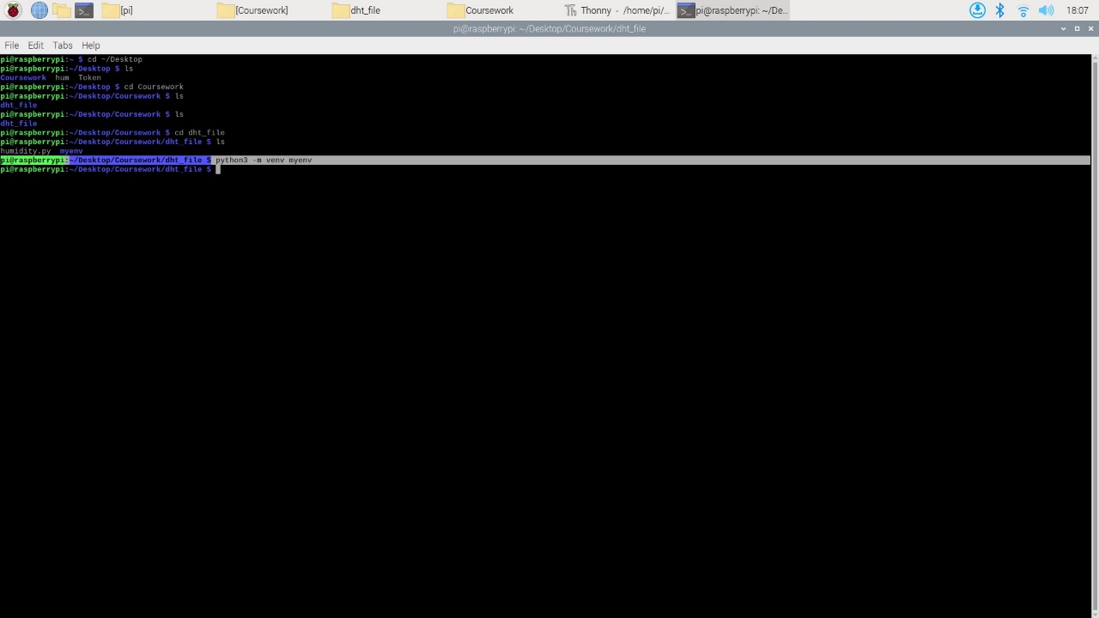

Figure 5

Created a virtual environment for this directory called **myenv.** This is the same directory where I installed the DHT library.

-**python3 -m venv myenv**

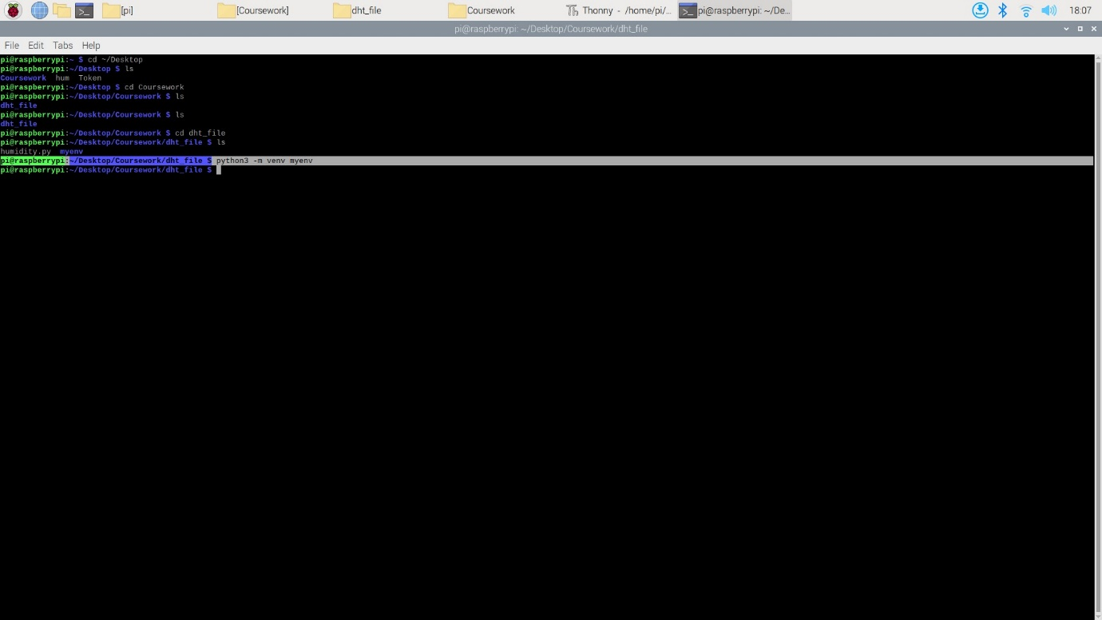

Figure 6

To activate the virtual environment

* **source myenv/bin/activate**

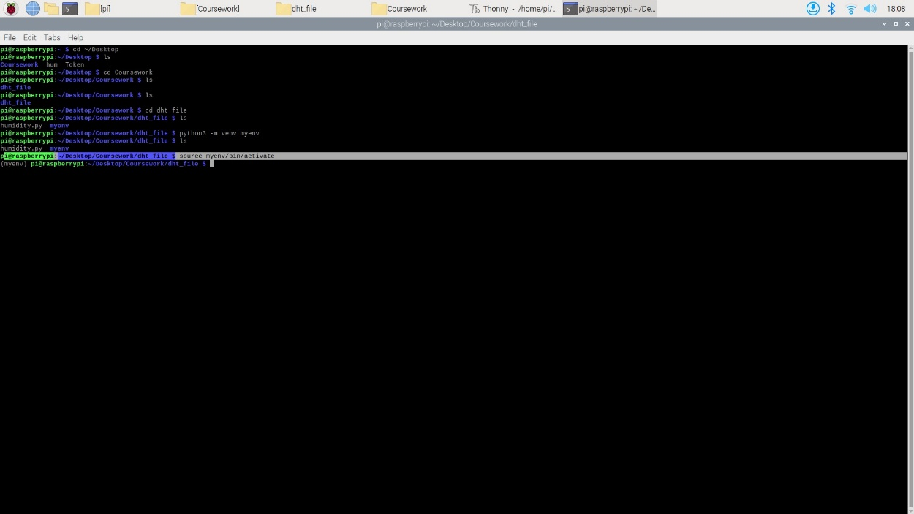

Figure 7

**Installing the Adafruit_CircuitPython_DHT Library**

Now that we are in our virtual environment, we can install the library, using the following command:

* **python3 -m pip install adafruit-circuitpython-dht**

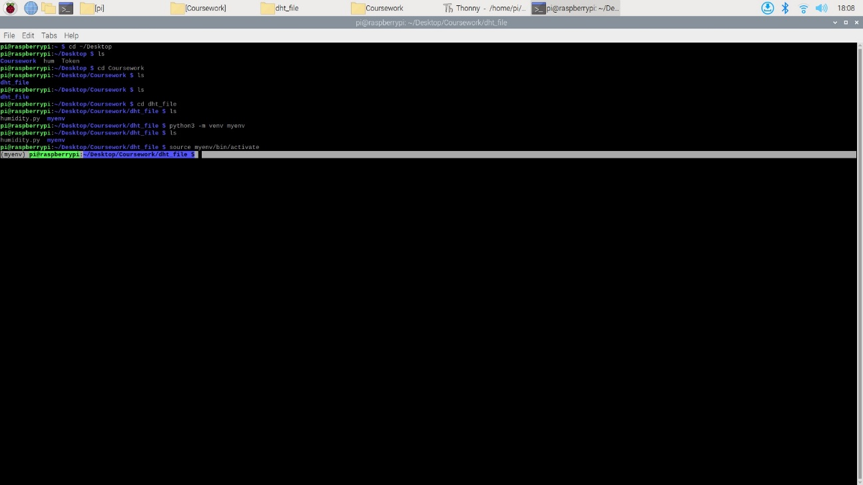

Figure 8

To install the library

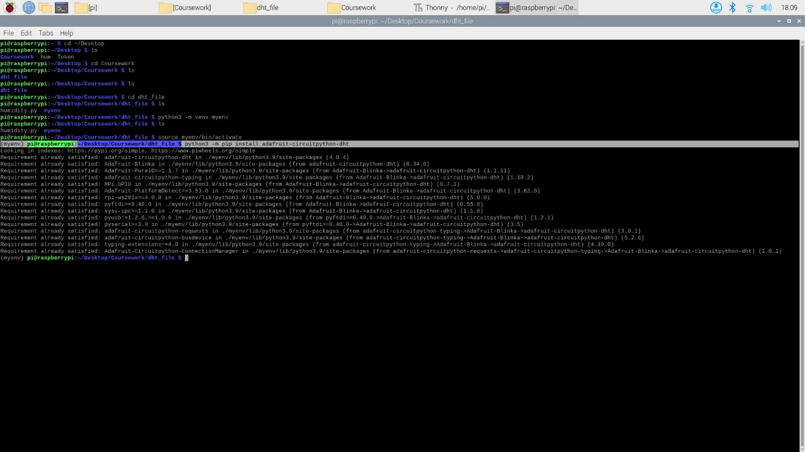

Figure 9

To run the python code to get the humidity readings

* python humidity.py

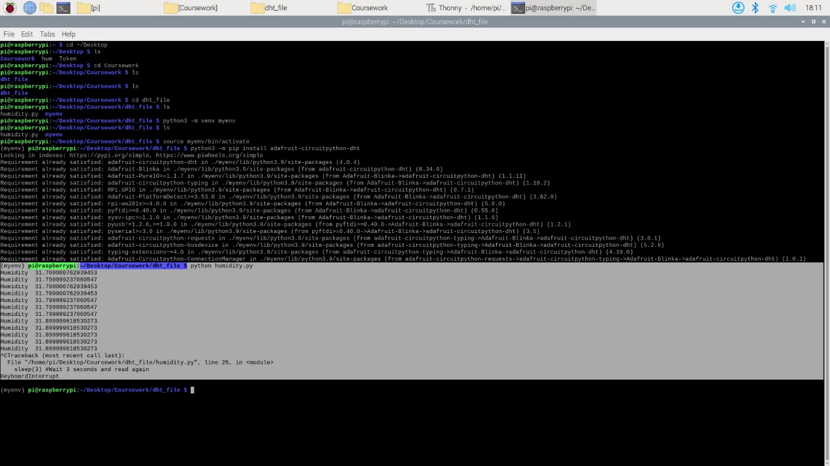

Figure 10

References:

<https://www.tech-sparks.com/raspberry-pi-dht22-sensor-project/>

<https://randomnerdtutorials.com/raspberry-pi-dht11-dht22-python/>